**Daily Scrum or Standup Meeting**

Team name: 5th Element

Scrum Master: Leonardo Craven

Date: October 25, 2021

| **Team Member** | **What did you do since the last scrum?** | **What do you plan to do before the next scrum?** | **What obstacles do you have?** |
| --- | --- | --- | --- |
| Leo | Completed sponsor tournament request page | Add CSS to previously worked on pages, work on tournament archive page | None |
| Gavin | Worked on request approval page | Complete request approval page | None |
| Andrew | Worked on dynamic home page, sponsor tournament selection page, set up AWS hosting | Push dynamic home page, finish sponsor tournament selection page | None |
| Brock | Worked on user type management page | Push user type management page, work on page for users to view currently registered tournaments | None |
|  |  |  |  |

# Burndown

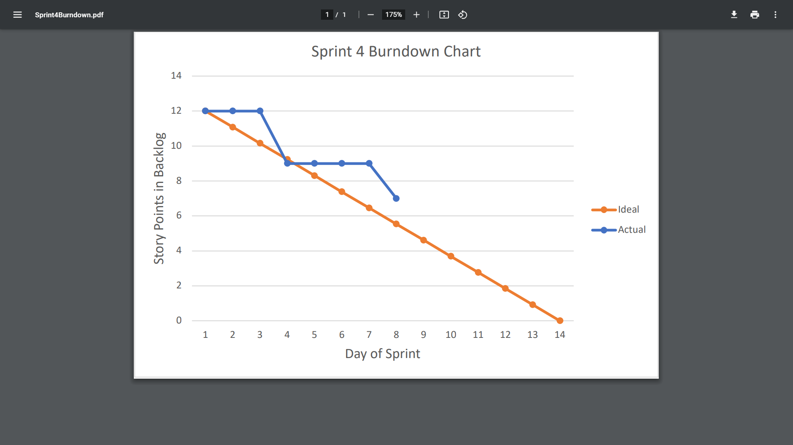

# Screenshot of you project board

